**Ideation Phase**

**Define the Problem Statements**

|  |  |
| --- | --- |
| Date | 24 June 2025 |
| Team ID | LTVIP2025TMID50169 |
| Project Name | iRevolution A Data-driven Exploration of Apple's iPhone Impact in India using Tableau |
| Maximum Marks | 2 Marks |

**Customer Problem Statement Template:** Create a problem statement to understand your customer's point of view. The Customer Problem Statement template helps you focus on what matters to create experiences people will love.

A well-articulated customer problem statement allows you and your team to find the ideal solution for the challenges your customers face. Throughout the process, you’ll also be able to empathize with your customers, which helps you better understand how they perceive your product or service.

Reference: <https://miro.com/templates/customer-problem-statement/>

**Example:** 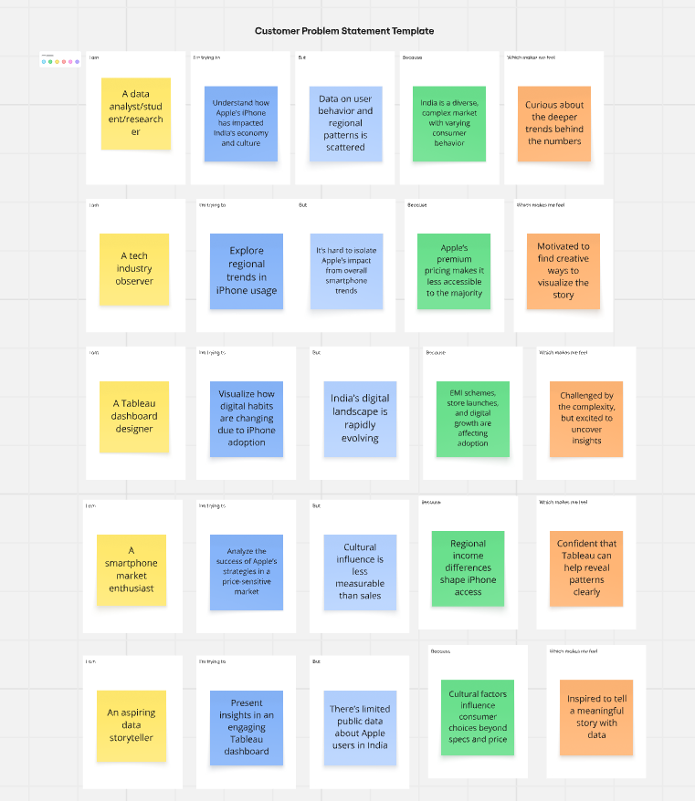

|  |  |  |  |  |  |
| --- | --- | --- | --- | --- | --- |
| **Problem Statement (PS)** | **I am (Customer)** | **I’m trying to** | **But** | **Because** | **Which makes me feel** |
| PS-1 | A data analyst/student/researcher | Understand how Apple’s iPhone has impacted India’s economy and culture | Data on user behavior and regional patterns is scattered | India is a diverse, complex market with varying consumer behavior | Curious about the deeper trends behind the numbers |
| PS-2 | A tech industry observer | Explore regional trends in iPhone usage | It’s hard to isolate Apple’s impact from overall smartphone trends | Apple’s premium pricing makes it less accessible to the majority | Motivated to find creative ways to visualize the story |
| PS-3 | A Tableau dashboard designer | Visualize how digital habits are changing due to iPhone adoption | India’s digital landscape is rapidly evolving | EMI schemes, store launches, and digital growth are affecting adoption | Challenged by the complexity, but excited to uncover insights |
| PS-4 | • A smartphone market enthusiast  • | Analyze the success of Apple’s strategies in a price-sensitive market | Cultural influence is less measurable than sales | Regional income differences shape iPhone access | • Confident that Tableau can help reveal patterns clearly  • |
| PS-5 | • An aspiring data storyteller  • | Present insights in an engaging Tableau dashboard | There’s limited public data about Apple users in India | Cultural factors influence consumer choices beyond specs and price | Inspired to tell a meaningful story with data |